Box Office Data Upload

Description:

In this module you will learn how to manually upload box office data for your organisation, via the Illuminate box office upload template. This guide is applicable to you if you host ticketed events, but do not use a box office provider that is integrated with Illuminate.

If you’re using a box office provider not integrated with Illuminate, many providers have the functionality to download data directly from their platform. Once downloaded, you can then copy and paste the required data into the Illuminate box office template.

Only users with “NPO Admin” level access can upload box office data for your organisation.

This module will cover:

- How to download the box office data template
- Overview of compulsory fields
- How to upload data to Illuminate
- How to confirm a successful data upload

- How to download the box office data template

To download the box office data template, select ‘Box Office Data’ from the left hand menu on the homepage.

Click on ‘Download Template’ on the screen displayed. This will download the template to your computer for you to open and insert your data.

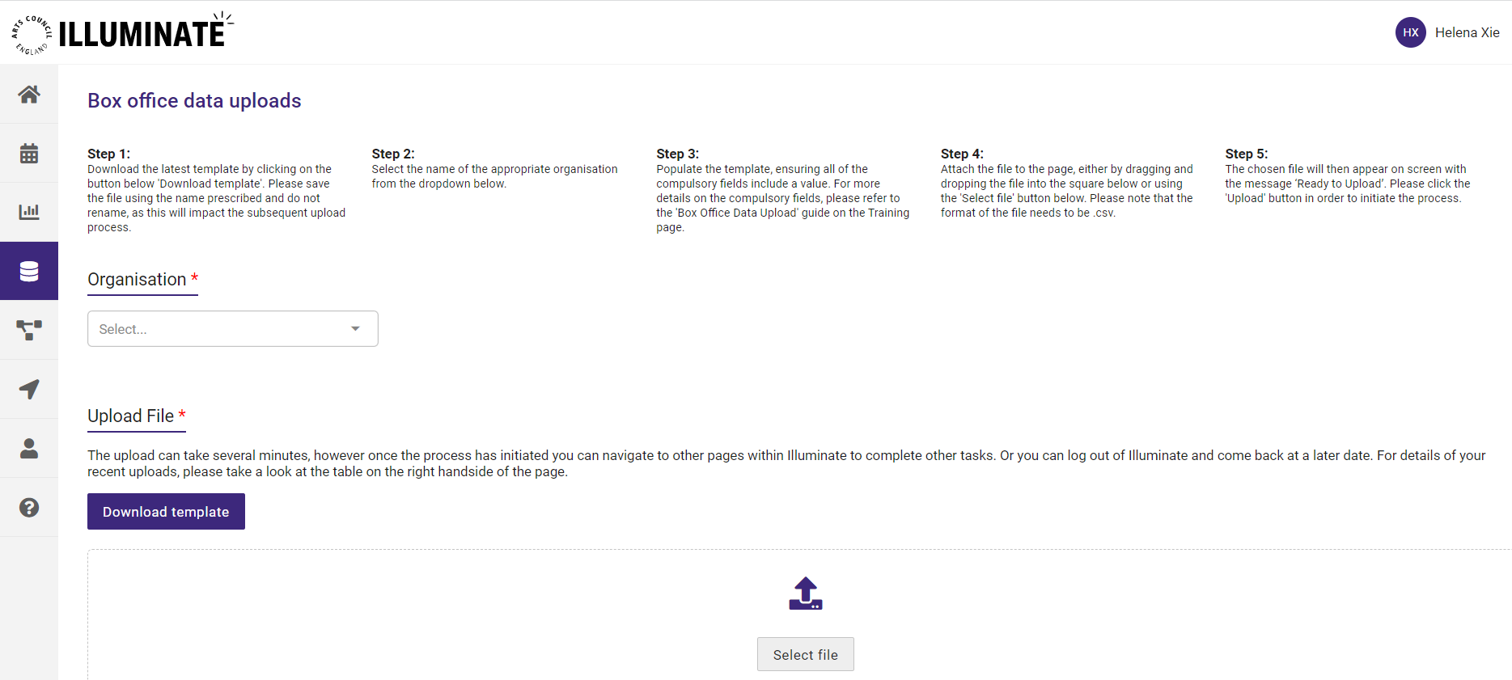

When saving the file to your computer, please make sure that:
- The file name remains the same
- The file name does not include a special character, such as !,?,()
this may occur when downloading the file more than once
- The file type is saved as a .csv file

- Overview of compulsory fields
This document contains the breakdown of all the key fields that need to be entered into the box office data template:
- Column A: Event Name
Name of the event
This is a compulsory, free text field for the box office data set

- Column B: Event ID
This must be the same as the ‘Box Office Reference ID’ that you created when creating the event.
If the Event ID is not the same as the ‘Box Office Reference ID’, this will impact the box office insights generated for your event. If you have not yet assigned a ‘Box Office Reference ID’ for your event, you add this by editing your event details

- Column C: Event Date
In the format of DD/MM/YYYY
This is a compulsory field for the box office data set

- Column D: Event start time
In the format hh:mm:ss
If you do not have the ‘ss’ information, enter 00 by default

- Column E: Ticket ID
Unique ID reference to the ticket
If you do not have this information for this field, enter n/a

- Column F: Ticket Cost
Amount (value in £) e.g. for a £12 ticket enter 12 in this field
If you do not have this information for this field, enter 0

- Column G: Concession flag
Either 1 (for concession) or 0 (no concession)
You must enter one of the above options, or you will receive an error message.
When there is no concession, ensure the following two fields (concession type and concessions/discount amount) are completed appropriately as explained below

- Column H: Concession type
Type of concession if the concession flag is 1 E.g. under 12. This is a free text field.
If there is no concession, enter n/a

- Column I: Concessions/Discount amount
This refers to the amount of the discount, eg. the full ticket price minus the concession ticket price. Enter the concession discount amount (value in £). E.g 8
If the concession flag is 0, enter 0

- Column J: Order ID
Unique ID reference to the order
If you do not have this information for this field, enter n/a

- Column K: Postcode (Booker)
E.g SW2 3JW
If you do not have this information for this field, enter n/a

- Column L: Datetime of purchase
In the format dd:mm:yyyy hh:mm:ss
If you do not have this information for this field, enter 00/00/0000 00:00:00

- Column M: Method of purchase
How the ticket was purchased e.g. online. This is a free text field.
If you do not have this information for this field, enter n/a

- Column N: Seat
E.g. 32
If this is not applicable to your event, or you do not have this information for this field, enter n/a

- Column O: Row
E.g. R
If this is not applicable to your event, or you do not have this information for this field, enter n/a

- Column P: Section description
E.g. Circle
If this is not applicable to your event, or you do not have this information for this field, enter n/a

If you leave a field blank, the file will not upload and will cause an error message, as seen in the example shown below:

THE TABLE BELOW WILL NOT UPLOAD DUE TO BLANKS
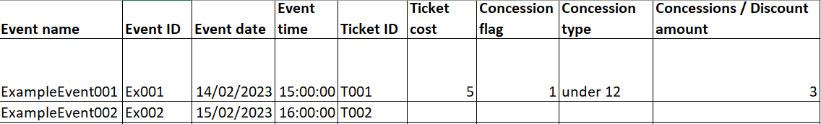

Enter n/a in the place of blanks in fields that are not numerical, for columns that are an amount/number, enter 0 (as shown below)

THE TABLE BELOW HAS BEEN COMPLETED ACCURATELY AND WILL UPLOAD
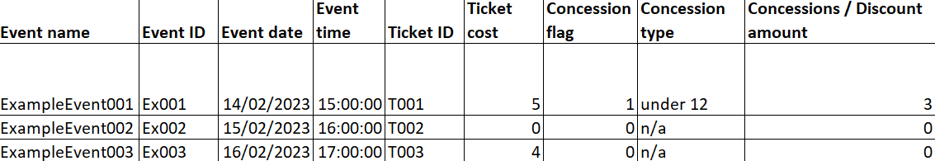
- Upload data to illuminate

To upload the box office data, navigate back to the ‘Box Office Data’ page on Illuminate.

Select the organisation from the drop-down list, that you would like to upload box office data for. The drop down will show you all the organisations you have access to.

If you are a member of a consortium, you can upload box office data for any organisation that you have been provisioned access to.

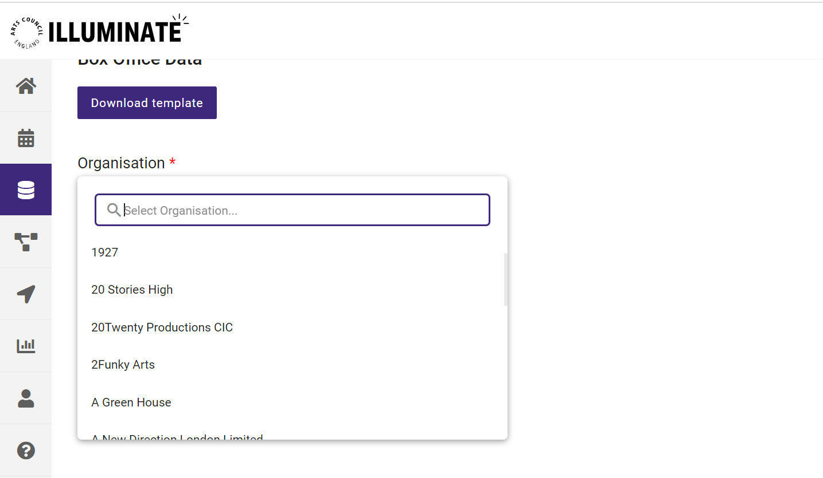

To upload the box office data, you can drag and drop the file into the ‘Upload File’ area on the screen or click on ‘Select File’ to select the box office data.

The format of the file must be in .csv.
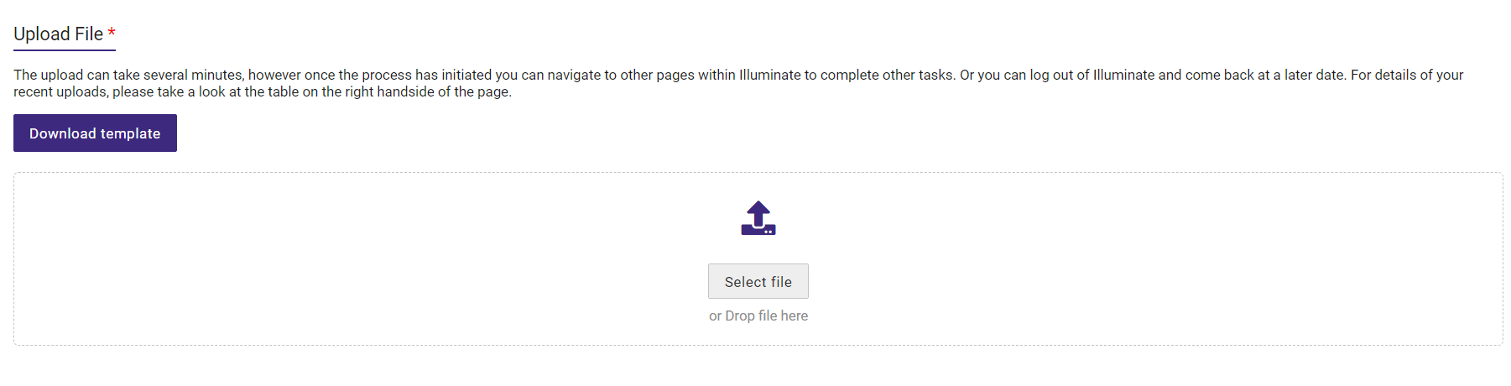

The chosen file will then appear on screen with the message ‘Ready to Upload’ and ‘File accepted for import’.

Now you can click ‘Upload’ to complete the process.

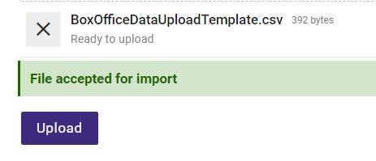

If the file is not in the correct .csv format, the data will not be accepted for upload, as shown in the example below.
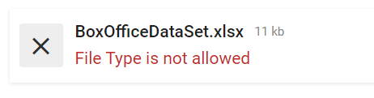

Additionally, if the file name has changed, or includes a special character, the file will not be accepted for upload.

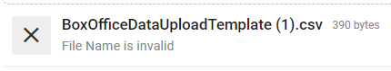

- How to confirm a successful data upload

To check if the file has successfully uploaded, scroll down the page to the ‘Upload status’ section. Here you can see the status of all previous box office upload attempts.

A successful box office data upload will show a green tick, as seen in the screenshot below:

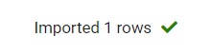

If the file upload was not successful, then you will receive an error message which explains the reason for the failed upload. For example:

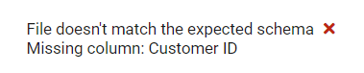

If this occurs, then please resolve the reason for upload failure and then re-upload your updated .csv file onto Illuminate.

Once you have uploaded your data using the template, you will be able to view the insights from your box office / ticketing data, within the Insights module.

