Grantium guidance for applicants
How to claim a payment

Version 2 – February 2018

To receive your funding payments from Arts Council England, you must submit payment requests. The payment request is where you attach any information we have requested from you to meet the conditions of your payment, and tells us that you are ready to receive the funds.

How to claim a payment

Log into your Grantium account using your username and password.

On the Welcome screen, click on the Submissions link in the grey bar to the left of the screen:

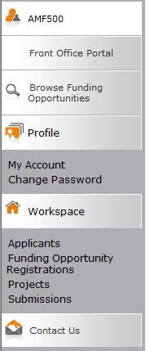

‘Submission’ is the name we use for any online form that you need to complete and submit. Clicking on this link will take you to a list of all your submissions, and you will need to filter the list to see the submissions linked to each project. This will include the eligibility questionnaire and application form you submitted, as well as the offer letter acknowledgement you received to notify you of the outcome of your grant.

This list will also show any Payment Requests that are due to be submitted.
Your first payment will show in Grantium once we have read and reviewed your acceptance of the grant. Any subsequent payments you are due to receive will appear in your Grantium account until closer to the time they are due.

To request your payment from us, click on the Open icon next to the payment request:

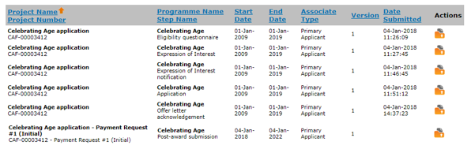

Within the Payment Request submission there are some screens that are for information only (which you can click Next to work through), and some that need you to enter some information or attach some documents.

The first screen is the Project information screen. You do not need to enter any information on this screen, but you can view your application form, award schedule or offer letter by clicking on the links at the top of the screen if you wish.

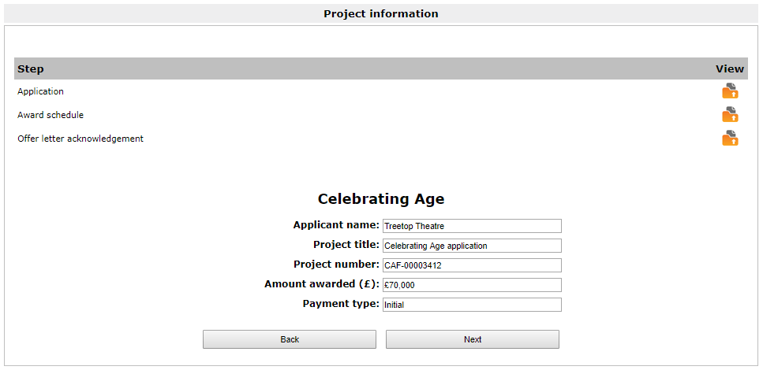

Click Next to proceed.

The next screen is the Payment request screen. Again, you do not need to enter any information on this screen, this is just a chance for you to review the amount of the payment you are requesting, and the date the payment is due to be made.

Please note that the Schedule due date is the date we expect to receive your Payment request, and not the date the money will appear in your account.

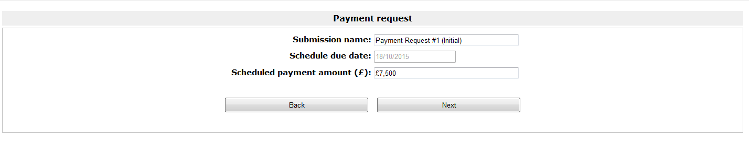

Click Next to proceed.

The next screen is the Payment conditions screen. This shows the details of any conditions you have been asked to submit before your payment can be released. For a first payment, you will always be asked to post us a copy of your bank details,
even if you have received funding from us before. You may also have been asked to provide other information specifically related to your project.

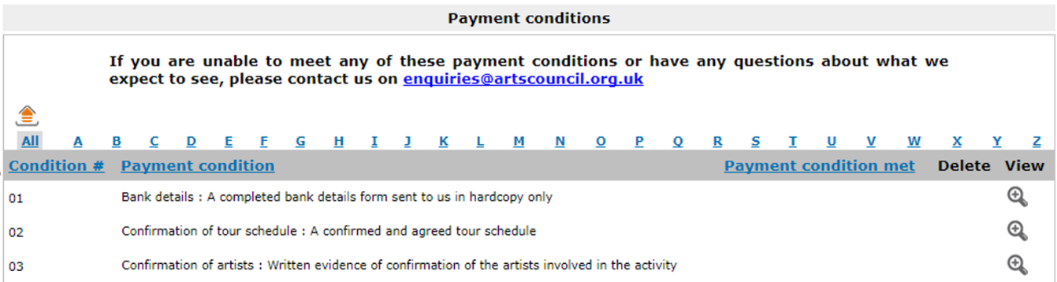

On this screen you need to confirm that you’re submitting information to meet the required conditions, but you will not upload any documents until the next screen (if necessary). To confirm you are submitting the required information, click on the View icon next to the relevant condition. This opens the Payment conditions details screen:

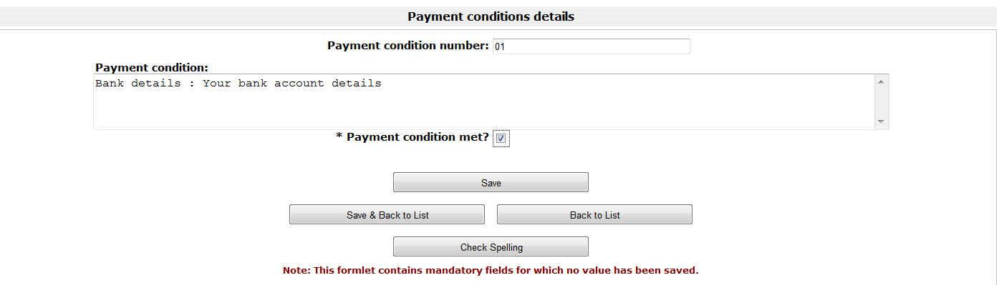

Tick the Payment condition met? box and then click Save & Back to List. The Payment conditions screen will then show that you have confirmed you have submitted information to meet the condition:

Click Next to move on to the next screen.

The next screen is Attachments. Use this screen to upload any documents you have been requested to submit before your payment can be released.

Please note: you will never be asked to upload a copy of your bank details on to Grantium. These must be sent to us by post.

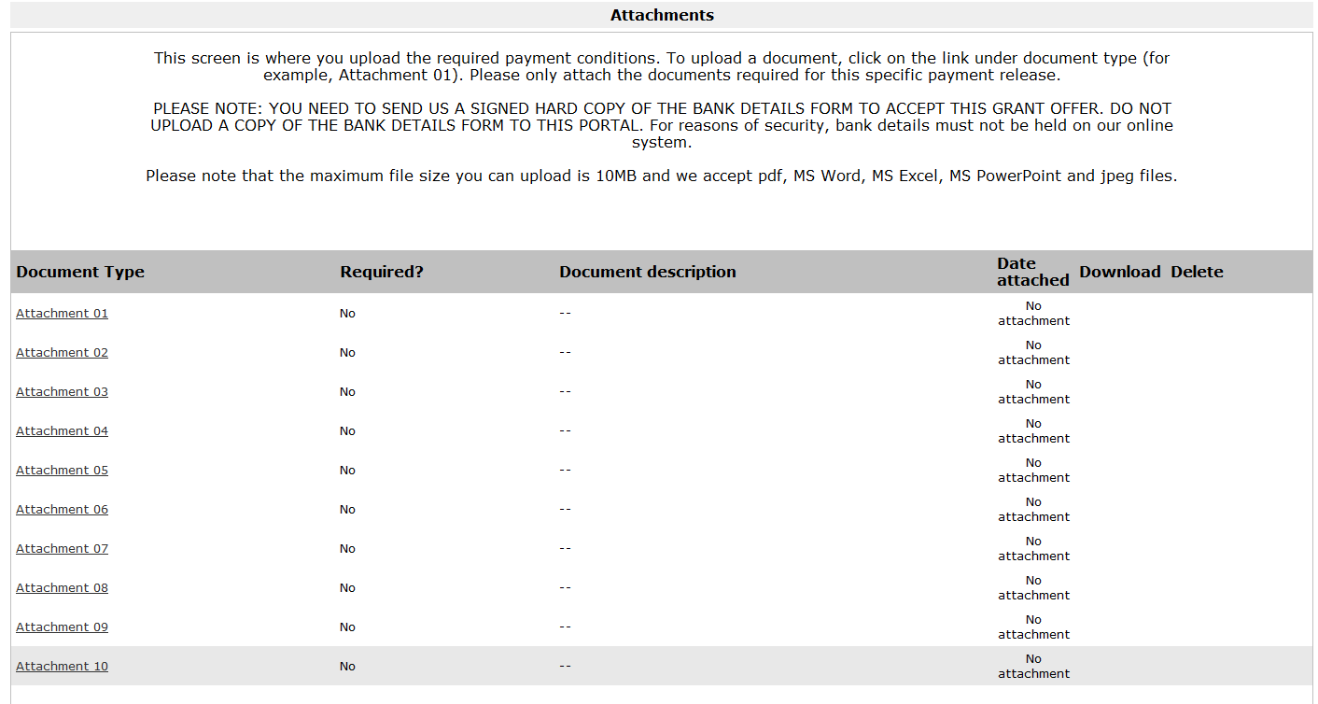

You can upload up to a maximum of 10 attachments on this screen. The maximum file size is 10MB and the document type can be PDF, MS Word, MS Excel, MS PowerPoint or jpeg.

Please note: If you have not been asked to provide any additional information for the payment you are requesting, you do not need to enter any information on this screen or upload any documents.

Once you have uploaded all the documents we have asked you to provide, click Next to move on to the next screen.

On the Declaration screen, confirm that you are authorised to submit the Payment request by ticking the relevant box.
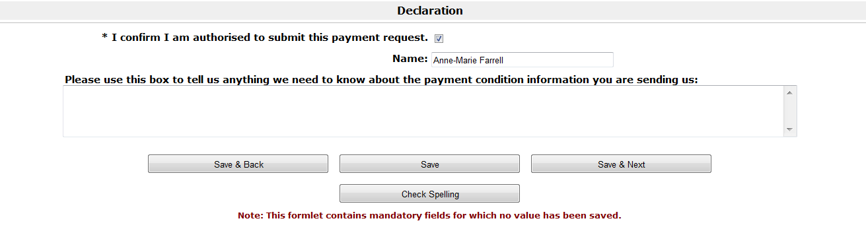

If you have any additional information about any of the payment conditions you have attached, you can use the free text box provided to tell us. You can also use this box to tell us if you’ve had any difficulty in providing the information we have asked for.

Once complete, click Save & Next to move on to the final screen.

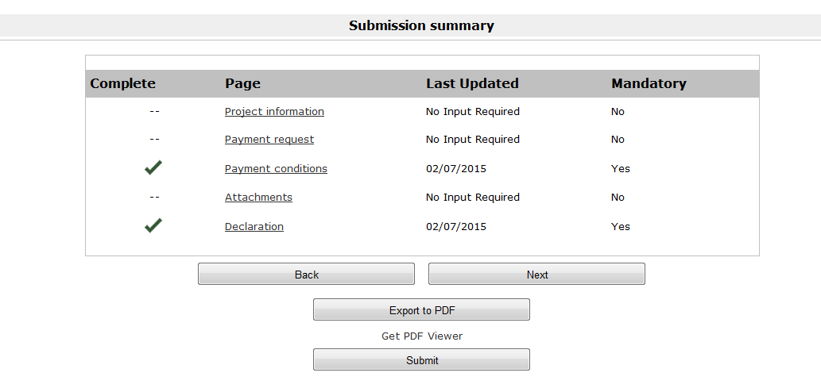
The final screen is the Submission summary screen.

Click Submit to complete the process.

Payment timeline
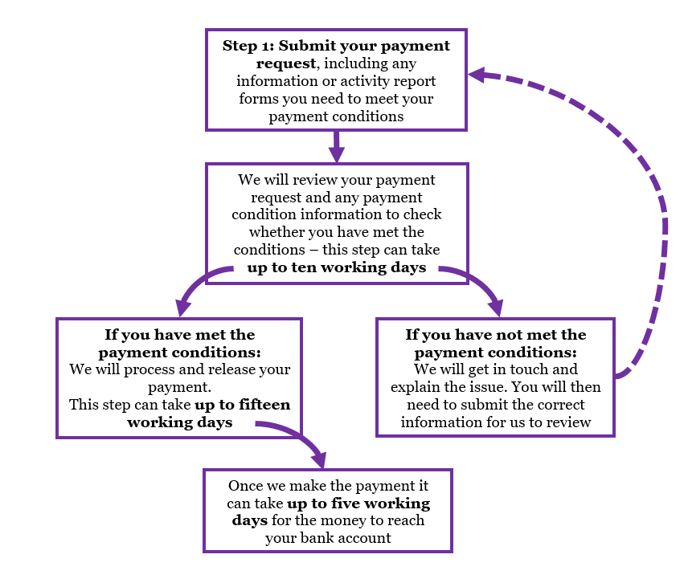

Further information and support

If you have any questions about the information contained in this document or require some assistance, please contact our Customer Services team on:

Phone: 0845 300 6200, 0161 934 4317
Textphone: 0161 934 4428
Email: enquiries@artscouncil.org.uk
Website: www.artscouncil.org.uk

